Student’s Name

Professor’s Name

Course Number

Date

Importance of the changes in English Language

Language throughout ages has always been associated with communication between people. The English language has been used either in informal or formal ways as a means of forming bonds and relations between people. David Shariatmadari provides this notion along with an idea that it is unnecessary to keep worrying about the influence of technology and use of loose grammar on English Language.

Shariatmadari provides evidence through the works of Ranulf Higden and David Crystal about the consistent mentions made about the deterioration of English throughout history. Despite the existence of these discussions since the last 400 years, Shariatmadari claims about the decline of the language. According to some authors, rapid usage of English as a medium of instruction in schools has created the opportunity for the development and preservation of the language (Aizawa et al. 839). Such internationally spread institutions develop and train children’s minds to always maintain grammar and fluently communicate with different individuals. These steps can be considered proofs which validate the claims given by Shariatmadari.

Shariatmadari also claims that technology plays a major role in the lives of younger individuals who develop certain language terms which deliver ease of communication using English. Shariatmadari supports this claim by arguing about the innovative mindset of youngsters being a force that acts in these language changes. Some authors have also mentioned a trend of using terms such as IDK (‘I don’t know’) and LOL (‘Laughing Out Loud’) in social media platforms such as Facebook and Twitter (Esteron 101).

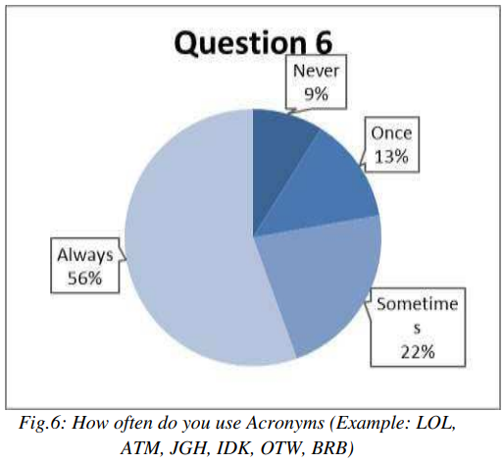

Fig 1: Survey showing significant use of trending English terms and abbreviations by youngsters in social media

Source: (Esteron 101)

Shariatmadari also claims a significant absence of an understanding of the English language during the Middle Ages. However, some authors on the contrary have claimed that utilizing skills such as interpretation and translation took place during this time to not only deliver messages but also to develop deeper political self-awareness (Nievergelt 16). Conflicts were reduced and relations were built strongly between clans and family members through communication involving English. Hence a dispute arises once this perspective presented by Shariatmadari, is taken into consideration. This claim requires further clarity and understanding as a result.

Hence, Shariatmadari develops a perception consisting of points or reasons why the evolution of English cannot be halted. It is clear from the ideas of the author that the urges presented by philosophers and people about maintaining a certain form of English can never put a barrier on the way this language is used by people today for communication worldwide.

Works Cited

Aizawa, Ikuya, et al. "Beyond the threshold: Exploring English language proficiency, linguistic challenges, and academic language skills of Japanese students in an English medium instruction programme." *Language Teaching Research* 27.4 (2023): 837-861.

Esteron, Maria Angela S. "Different language usage on social media." *International Journal of Advanced Engineering, Management and Science* 7.3 (2021): 093-104.

Nievergelt, Marco. "Translation into English." *The Oxford History of Poetry in English, Volume 3: Poetry in English: 1400-1500, edited by Julia Boffey and ASG Edwards* 1 (2023): 46-60.

Shariatmadari, David. “Why it’s time to stop worrying about the decline of the English language” *The Guardian.* <https://www.theguardian.com/science/2019/aug/15/why-its-time-to-stop-worrying-about-the-decline-of-the-english-language>